Dear Editor:

Thank you and your team for dedicating time to review our paper. The proposed revision suggestions are very helpful for improving the quality of this paper. For the convenience of reading, we provided a brief explanation of the modified content according to the suggested clauses.

1. The title submitted online differs from the title in the manuscript. They should be identical.

Modification instructions: We have modified the title submitted online.

2. Some terms remain confusing (see the attached file). I can only go through the abstract. You and your co-authors need to revise the manuscript carefully on the technical front. Please seek professional English editing service and upload a certificate in your next submission.

Modification instructions: We have revised the manuscript carefully, and sought a professional team for English editing service. Editing certificate is as follows.

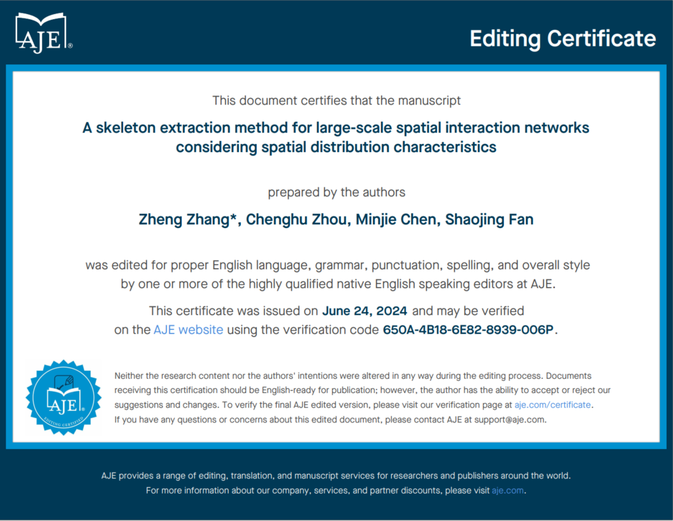

3. Thanks for sharing data and codes. Please have both data and codes at the same site, so reviewers can access them in one click. Also, the Gitee site and its linked data site include the first author's name of this manuscript. Please anonymize the site and all codes for double-blinded peer reviews. In addition, please provide a file with step-by-step instructions to reproduce findings (figures, tables, numerals) reported in the manuscript. I see the tutorial on the Gitee site. However, the instruction file should have specific instructions for each figure (table, or number), such as Figure 3.

Modification instructions: We have anonymized the related information of Gitte, and uploaded the data to the ShareBikes folder on the same link of the source code. As for specific instructions, we have uploaded an attachment (See attachment 1 for details).

**In Addition, we have provided an explanation about the reason why the author Minjie Chen cannot provide an institutional email (see attachment 2 for details).**

Thank you again for your valuable suggestions.

Yours sincerely,

Zheng Zhang

Institute of Geographic Space Information,

Information Engineering University, Zhengzhou 450001, China

E-mail: [giser_zzy@infu.ac.cn](mailto:giser_zzy@infu.ac.cn)

**Attachment 1**

**Instruction file with step-by-step instructions for each figure**

1. **Installation Tutorial**
2. Install QT 5.12.10 and configure QT environment variables.
3. Installing Python 3.10.9 and configure Python environment variables.
4. Modify the configuration path in the bin/qgisbuildpath.txt file to the path corresponding to the file on your computer.
5. Open the geograph.sln file in the src folder, compile and run it
6. **Instructions for Figures and Tables**

The step-by-step instructions are as follows:

2.1 Table 1

(1) Run geography.

(2) Click on icon “” and open the graph data loading dialog. Load four network data from the “ShareBikes” folder, and fill relevant information in the corresponding line edit box. Click the ok button, and then the visualization result of networks is displayed. (Take the Washington data as an example)

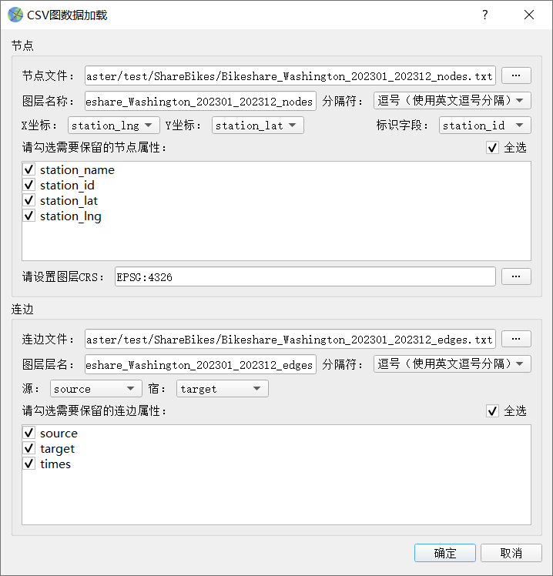 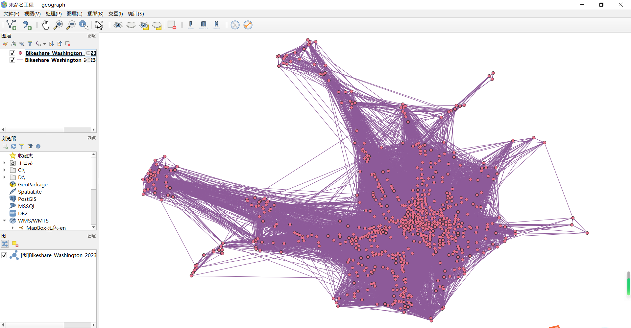

(3) Click on menu “” and open the statistical dialog of network. Click the ok button, and then the diagram of CDF curves is displayed. (Take the Washington data as an example)

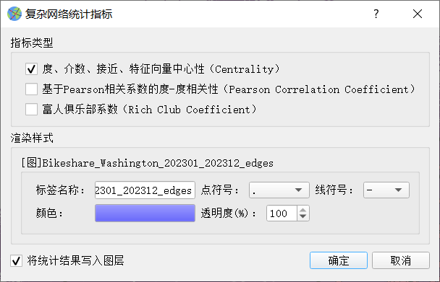 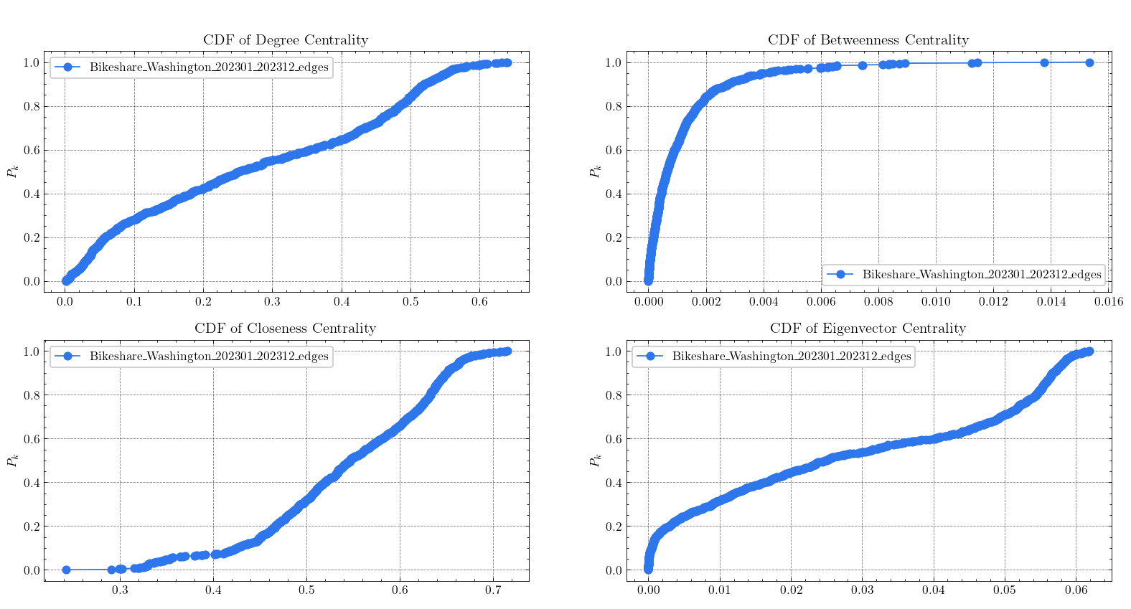

(4) Close the diagram of CDF curves, and select the node layer. Then, click the right button and pop-up the context menu. Click the “open attribute sheet” item, and the values of DC, BC, CC and EC are shown.

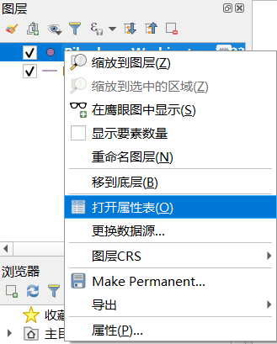 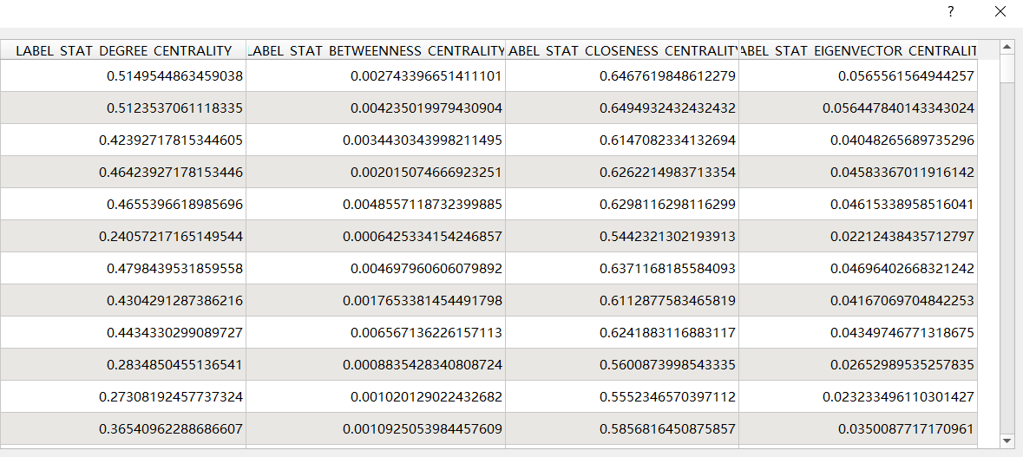

As for the average values of DC, BC, CC and EC, you can find them from the console. (Corresponding to the third row in Table 1)

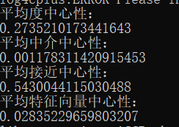

(5) Click the menu “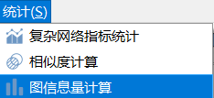” and pop-up the dialog of network information amount. (Corresponding to the third row and last column in Table 1)

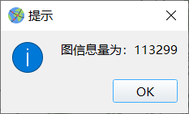

2.2 Figure 1

Right click on the node layer item, and open the properties dialog. Select an indicator as the grading value, and click the ok button. (Take the DC as an example)

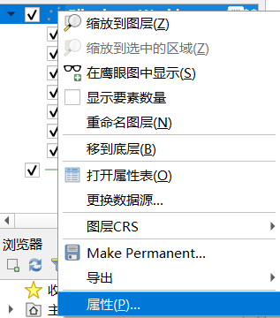 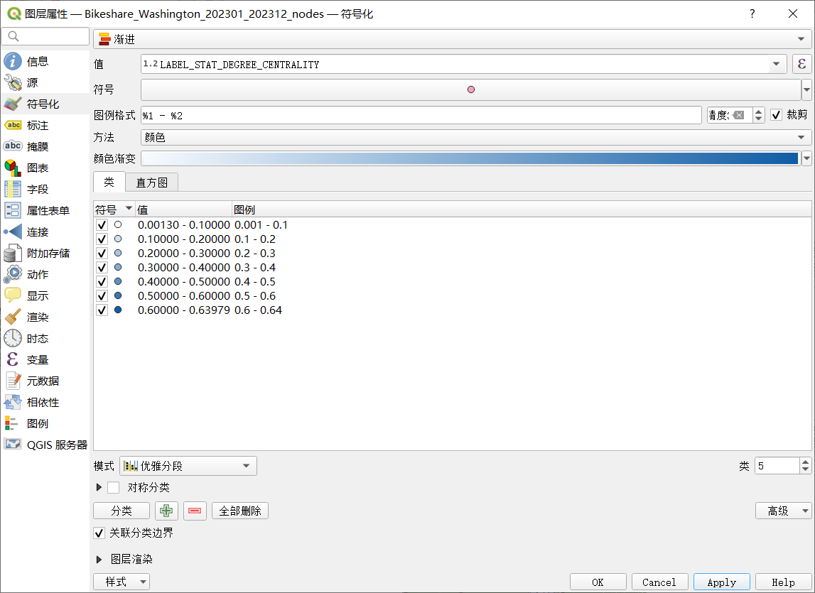

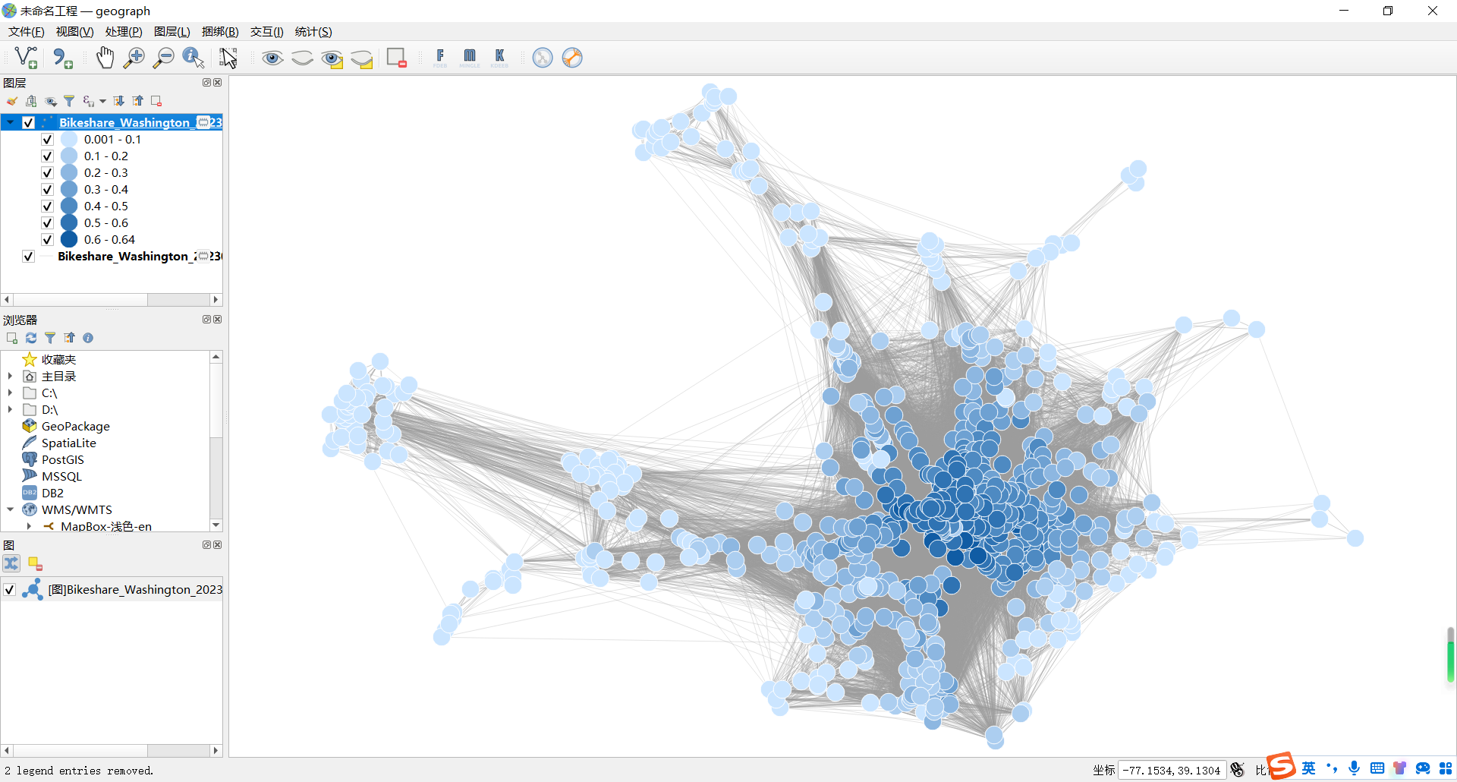

(Corresponding to the result of Washington in Figure 1)

2.3 Figure 3

(1) Click the menu of clustering, and open the dialog.(Take the Washington data as an example)

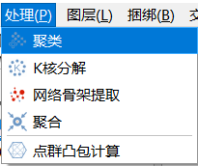 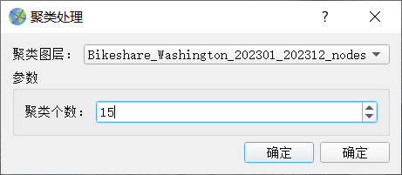

(2) Click the ok button to show the diagram of clustering. (Corresponding to the result of Washington in Figure 3)

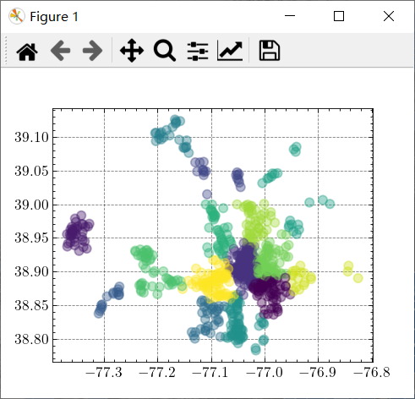

2.4 Figure 4

You can install a VS Code software to run the code, or run the Python script directly. (drawCurves.py in the “Python” folder)

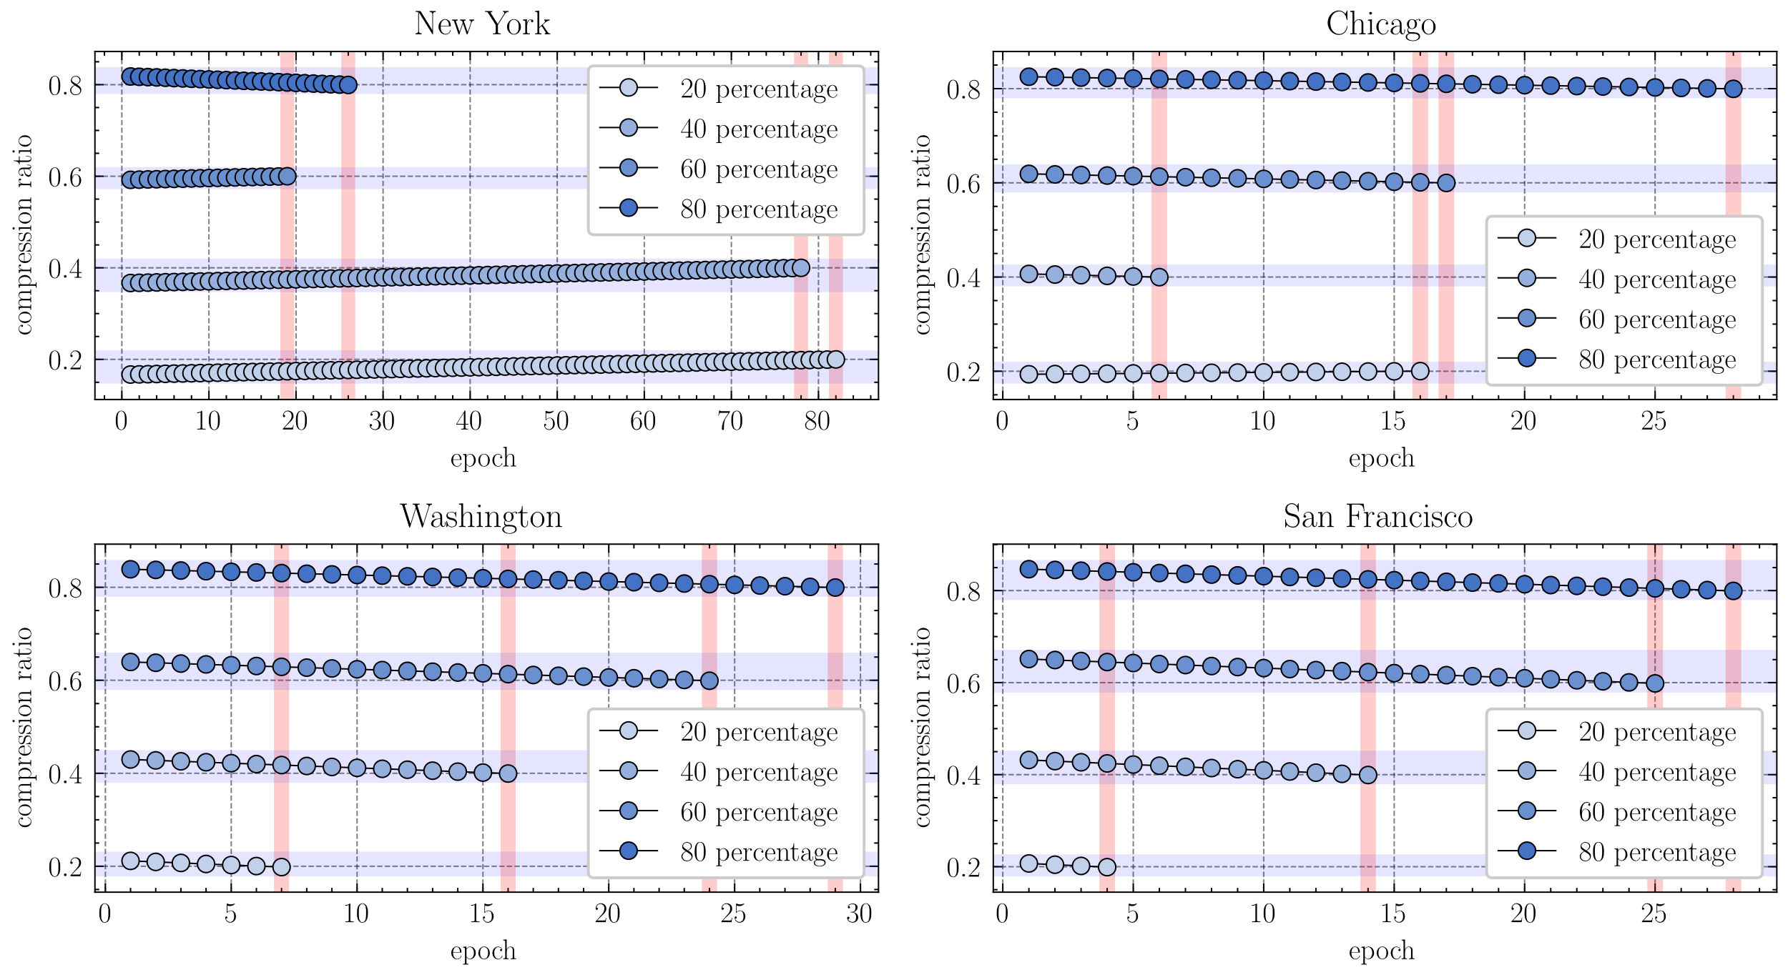

2.5 Figure 6

(1) Calculate indicators (DC, BC, CC, and EC) for spatial interaction networks. (Please refer to 2.1 for the corresponding operation steps)

(2) Clustering for nodes of spatial interaction networks. (Please refer to 2.3 for the corresponding operation steps)

(3) Click the skeleton extraction menu to open the dialog. There are 5 skeleton extraction methods in the drop-down menu, among which the first item corresponds to the proposed method in this paper.

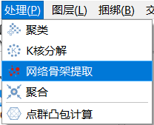 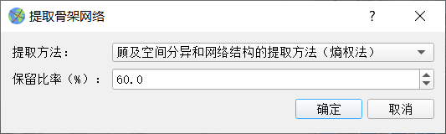

(4) Click the ok button to execute the skeleton extraction. (Due to the large scale of data in spatial interaction networks, extraction operations may take several hours)

2.6 Table 4

Please refer to 2.1 (1)-(3) for the corresponding operation steps. The difference is that multiple networks need to be selected simultaneously to display multiple CDF curves. (Press the Ctrl key for multi-selection)

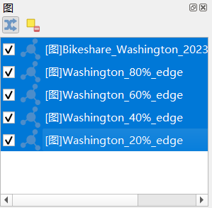 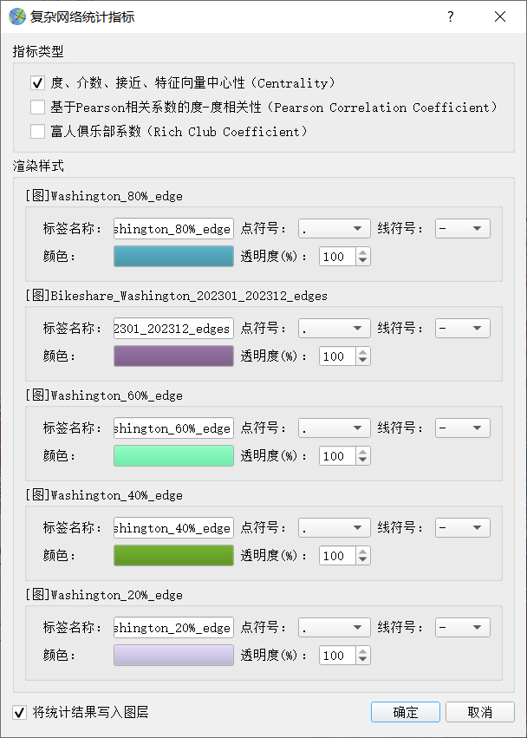

2.7 Figure 8

(1) Click on the menu item of convex hull calculation to open the dialog.

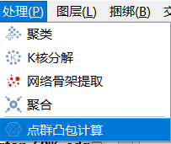 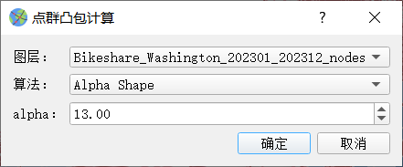

(2) Select the Alpha-shaped Algorithm in the drop-down list. Set the value of alpha to 13. Click the ok button. (Take Washington as an example)

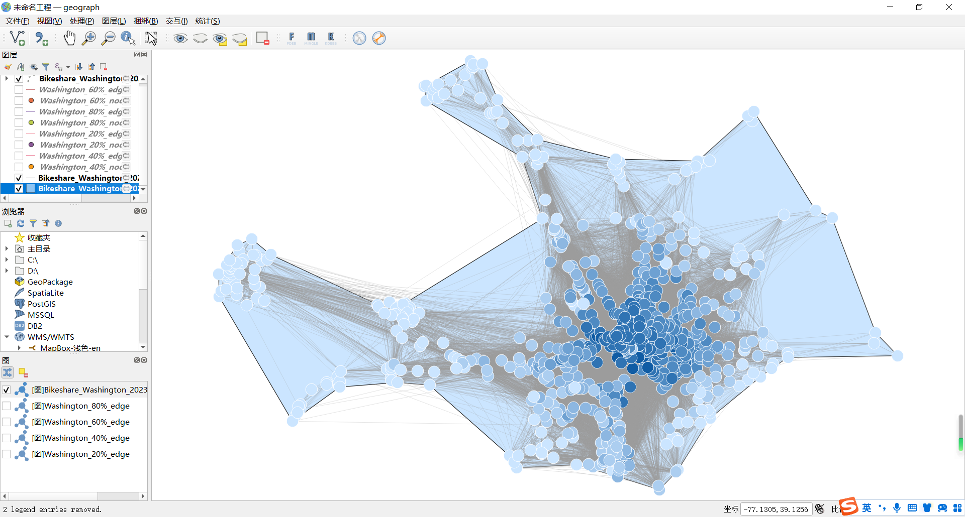

2.8 Table 5

(1) Calculate the convex hulls of networks referring to the steps in 2.7.

(2) Click on the similarity calculation menu item to open the dialog.

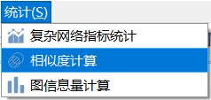 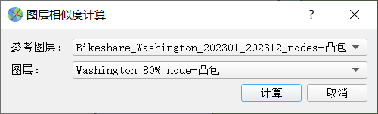

(3) Select layers in the drop-down list for similarity calculation. Click the ok button to show the results. (The first value is the length similarity, the second value is the area similarity, and the third value is the center offset)

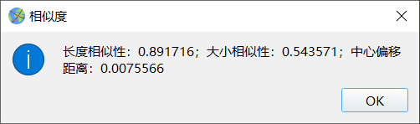

**Attachment 2**

Dear Editor:

I would like to clarify that I did not use institutional email addresses for this submission due to specific circumstances. My school is Information Engineering University, Zhengzhou, Henan, China. Currently, my organization does not provide institutional email addresses for team members, which is why I have used personal email addresses for communication and paper submission.

In order to prove the authenticity of my school, I provide articles published in your journal by other authors of my school:

1. Zhou J, Ben J, Huang X, Wang R, Liang, X, Ding J, Liang Q. Efficient cell navigation methods and applications of an aperture 4 hexagonal discrete global grid system. International Journal of Geographical Information Science, 2022, 37(3), 529–549. <https://doi.org/10.1080/13658816.2022.2125972>
2. Wang R, Ben J, Zhou J, Zheng M. A generic encoding and operation scheme for mixed aperture three and four hexagonal discrete global grid systems. International Journal of Geographical Information Science, 2020, 35(3), 513–555. <https://doi.org/10.1080/13658816.2020.1763363>

Additionally, I have included relevant papers for the editor's verification. The articles are as follows:

1. Zhao X, Cao Y, Wang J, Fan X, **Chen M**. A hierarchical spatio‐temporal object knowledge graph model for dynamic scene representation. Transactions in GIS, 2023, 27(7): 1992-2016. https://doi.org/10.1111/tgis.13109
2. Yang Z, Hua Y; Cao Y, Zhao X, **Chen M**. Network Patterns of Zhongyuan Urban Agglomeration in China Based on Baidu Migration Data. ISPRS International Journal of Geo-Information. 2022, 11(1): 62. https://doi.org/10.3390/ijgi11010062

I fully understand and appreciate the necessity of using institutional email addresses. I assure you that my research work is fully supported by my institution. If the editors need any additional information or have any other related issues, I will actively cooperate and provide the required supporting documents.

Yours sincerely,

Minjie Chen

Institute of Geographic Space Information,

Information Engineering University, Zhengzhou 450001, China

E-mail: [cmj202112@163.com](mailto:zhao_xinke@163.com)